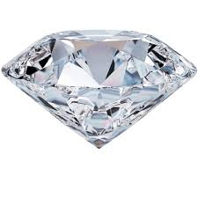**DIAMOND**

**Name:** Hope Diamond

**Brand:**  Harry Winstone

**Model#:** 001

**Color:** Transparent

**Price: $250 million**